AFGAN COMMUNITY OF IRELANDAFGAN COMMUNITY OF IRELAND

AFGHAN
COMMUNITY OF IRELAND
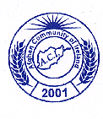

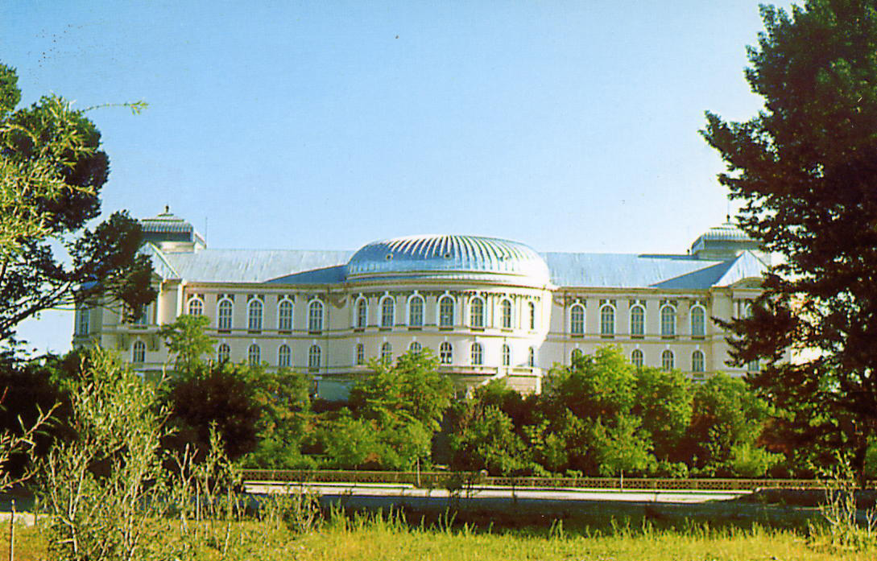

Afghanistan Darlahman monument

INTRODUCTION

Afghanistan is located in the middle of Asia. It has 5000 years of cultural history and was the first cradle of civilization, democracy and economic activities. Afghanistan had a network of scientific centres, universities and institutions from which hundreds and thousands of students graduated and worked for the development of Afghanistan.
Unfortunately during 23 years of war our way of life has been destroyed. Our educated people such as scientists, government employees and artists, have emigrated to Europe, America, Canada and Australia. While over 3 million people went to Iran and Pakistan.

A number of Afghan living in Ireland who were students, government employeee or artists have come together to establish a committee.

• To be active in a international cultural exchange.

• To celebrate Afghan special holidays.

• To organise history and geography lessons for children.

• To organise mother tongue and cultural classes for children.

• To organise translator service for members of Afghan
community.

• To act as a support network for Afghans living in Ireland.

• To act on behalf of Afghans living in Ireland.

• To publish a regular newsletter.

• To establish links with other ethnic cultural associations in
Ireland and abroard.

• To defend human rights.

• To advise and assist other community organisations based in
Ireland running programs in Afghanistan.

AIM and OBJECTIVES

ACTIVITIES
As the work group of the Afghan association is new in Ireland, some members collectively and individually have been active in cultural programs in Ireland, they voluntarily participated in a number of cultural programs.

New Year Celebrations

Afghan community celebrated New Year on Sunday 22nd March
2003, in the Catherine Mc Auley Centre, with the participation of
Afghan and Irish guests from 6pm to 11pm.

John Patrick Kavanagh who was the guest of the ceremony gave
a clown presentation for the children and audience.

The history of Afghan New Year and traditional customs was
compiled and published in Persian and English by Nasruddin
Saljuqi.

At the end Afghan national dance was performed by the nations
and traditional Afghan food served.

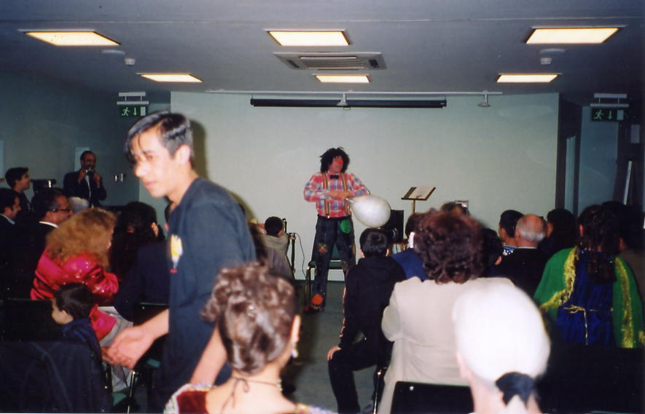

John Fitzpatrick doing the Clown Presentation

Media and interviews
Giving information about Afghan culture and Afghanistans viewpoint on national radio. Morning Ireland, Radio One World, CRC, FM Radio, RTE 1,2,3.

Interviews with Sunday World, Sunday Independent,
Sunday Tribune, Irish Times, Irish Mirror, Galway Press,
Galway Advertiser.

Giving information about Afghan culture to the Media.

Presenting Afghan music on CD, Audio cassettes to Irish
Radio and TV.

Establishing links with other cultural associations both in
Ireland and overseas.

Supplying articles and reports to the Afghan organisations in
London, Iran and Germany.

RESEARCH WORK:
Prepared a small publication about the history of Islamic calligraphy in Afghanistan. Galway library January 2002
Compiled and translated an exhibition, which was presented in Ireland from Persian Arabic into English.
Compiled and translated a biography of Herati, calligraphers and painters and artistic foundation, in Persian and English.
Work on Music and Theatre.

WORKING GROUP:
- Afghan community translator service is available to help other organisations when there is a requirement.

- A group of educated and experienced persons are working on some projects to develop our aims.

- A group of cultural and educated people is going to publish a regular newsletter.

- The Association encourages all Afghans living in Ireland to participate in meetings and assist its members in producing the reports and activities.

- The Afghan working group is voluntary, they have received no monetary support for their work so far, we would welcome any assistance from any individual or organisation.

World Refugee Day:

Afghan children entered into the story competition which was organised by (UNHCR) and the reception and integration agency.

In this competition Shabnam Azad and Shamoon Saljuqi won the prize with their personal story.

The award ceremony was organized by (ARN, UNHCR, NCCRI and SPIRACII) on June 20th 2003.
In this ceremony John Patrick Kavanagh from Cradle organisation was nominated and outlined as a suitable person by the community and he also won a prize.

Pictured from left to right: Shabnam Azad, Noel Waters (director, RIA) Shamoon Saljuqi, George Rusu, at the award ceremony for the Page 3 story competition.

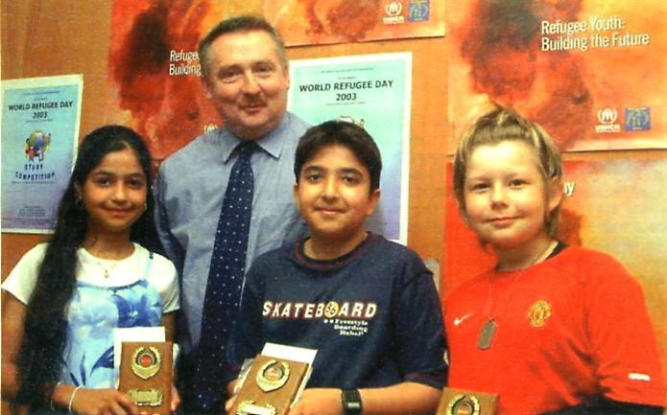

ADDRESS

Afghan Community of Ireland Association
20 Ashington Gardens,
off Navan Road,
Dublin 7
Ireland

Telephone: 353 -1 - 868 3577

Mobile: 085 – 711 8340
E-mail: afgcommunity@hotmail.com

Web Site: http://nasrudinsaljoqi.tripod.com



